3 Comments
interview: paulette martsolf, owner & designer of allie-coosh & accoutrer
Posted by Leslie Chatman on October 30, 2012 in clothes, interviews, jewelry, services, style
Paulette Martsolf, owner/designer behind Allie-Coosh & Accoutrer
Fashion designed, crafted and sold right here in the city of Dallas?! YES! A staple of Snider Plaza, Allie-Coosh, has been the go-to location in the area for shoppers to find beautifully designed casual, day, career and evening attire for 20 years. Every item in the store is crafted in Dallas at the brands studio.
Known for her signature fabrics and innovative designs, Newfoundland native Paulette Martsolf is the designer behind all of the fabulous garments and jewelry at Allie-Coosh. Diverse, bold and easy to wear best describes her aesthetic.
Recently I spent some time with Paulette. Enjoy my chat with her as she shares her inspiration, thoughts on Dallas style and suggestions of the top five items of clothing every woman should own.
Allie-Coosh is known for many things but is primarily known for the signature fabric used to craft many of the pieces. Tell me about your signature fabric.
Our custom dyed fabric comes in 45 colors. Women love it because it works on all figure types, is washable and packs well. We use this fabric to create many of our daytime, career and evening looks.
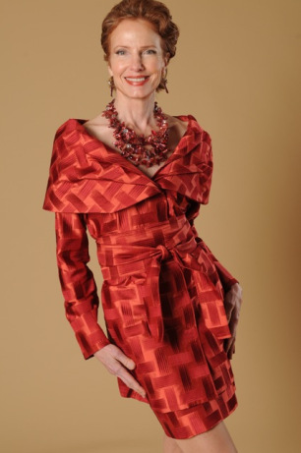
I love this skirt and jacket!
Your designs are so diverse and dynamic. Where do you find inspiration?
The clothing designs in Allie-Coosh and our jewelry line Accoutrer are constantly evolving. I read European trend magazines and I watch color trends.
One of my favorite things to wear are pants and I have designed some crazy pants! I also know my clientele and I try to satisfy them with classic shapes that are timeless.
Do you offer custom design options for women?
Oh, yes! We are here to help women find designs that are best for their body so it is easy to change a sleeve or color or whatever we can to help her create a personalized collection she will love and enjoy wearing. Because the items are crafted right here in Dallas, custom items can be completed in a couple of weeks.
Describe Dallas style to me.
I have been in the metroplex 23 years and it has evolved into a city with chic, ecclectic style. It’s southwestern, it’s funky, it’s edgy…
What are the top five items of clothing every woman should own?
Two pants styles, a narrow cut and a wider/dresser cut are essential. A sleeveless camisole, a tunic with three-quarter length sleeves, a little black dress and a jacket or vest. Vests offer so much flexibility.
When you visit Allie-Coosh, you are likely to find Paulette there with her amazing staff. ”Our employees are the essence of the store. They are good energy!”, says Paulette. I agree.
Allie-Coosh caters to women of all age groups; there is something there for everyone. Aside from the clothing and jewelry, I am addicted to scarves and they have a great selection to choose from.
Be sure to stop by Allie-Coosh the next time you are in Snider Plaza!

