Rock Star
05/16/2012 10:08 AM -- WHERETRAVELER ®
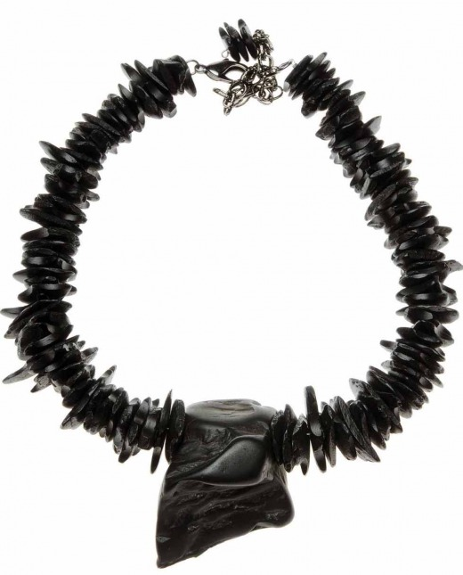
©ACCOUTRER
Finding that elusive Mother’s Day gift may have gotten easier. Accoutrer, a new jewelry line available at Allie-Coosh and online, makes an enduring statement of cultured elegance and panache for its wearers. Voted Best Jewelry by People Newspapers, designer and owner Paulette Martsolf blends modern aesthetic with ageless design for lustrous, one-of-a-kind pieces that complement any style. Each organic piece is individually crafted with care with a special focus on fossils, minerals and semi-precious stones. Martsolf also provides custom-design services so even the most fastidious shopper can be treated with the perfect gift of accessories. From exceptional earrings to novelty necklaces, Accoutrer certainly has Dallas (and now the online universe) covered in chic sophistication. 6726 Snider Plaza, 214-363-8616, www.accoutrer.net —Loron Hays

Read more: http://www.wheretraveler.com/dallas/rock-star#ixzz2dleMgssd

