May 16, 2012
Accoutrer: Stunning Hand-Crafted Jewelry by Designer Paulette Martsolf

Check out the picture above. Designer Paulette Martsolf of Allie-Coosh from Newfoundland, has got style. Times ten. And lucky for us, she sells her clothing and jewelry designs, so we too, can rock.

Her Accoutrer jewelry line (means all decked out) enters around fascinating materials such as fossils, minerals, crystal, pearl and metals, as well as novelty and custom pieces and earrings. But it's what she does with these materials that makes her creations such stand-outs. These bold pieces are wearable art, sculptures that never just blend into the background, but make you take notice. I love the heft and weight of them, though they're not all that heavy. You can just feel the history and quality of the piece. It's a fantastic feeling wearing elements of the earth around you - talk about an amulet. And no two pieces are identical, so you not only get a spectacular piece, it's also one-of-a-kind.

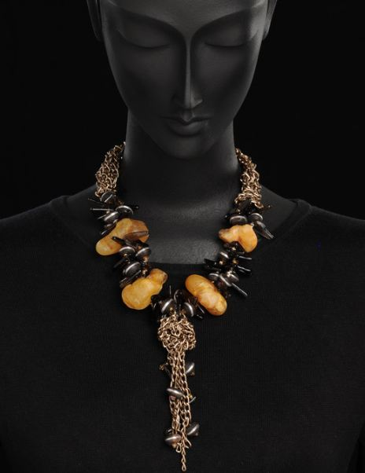

I cannot get enough of my new Fossil stunner, a combination of raw amber, smokey topaz, silver inlay, wood beads, crystal and chain. It is not simply au courant, it's avant-garde. The juxtaposition of high style with heavy metal makes it so much more than anything in your current collection. No matter whether you're rocking a soft white tee or a clingy, silver dress, this necklace will add some much needed edge and elevate your style profile in an instant.

Buy Accoutrer Jewelry and you're not merely getting an accessory - you're getting STOP 'EM IN THEIR TRACKS works of art.

So go and shop Accoutrer Jewelry now.

