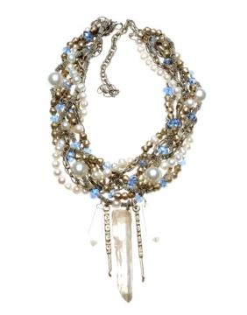

Paulette Martsolf has captured the attention and respect of fashion aficionados for more than 20 years throughout Dallas and the Southwest yet now has a global reach with the debut of www.accoutrer.net. This new online jewelry boutique features the designer's hand crafted one-of-a-kind necklaces, bracelets, brooches and earrings. Paulette also, however, allows shoppers to create their own jewelry designs via her site. Guests to her online boutique can choose from rare jewelry elements such as alloys, minerals, pearls, crystals and others shown throughout her site as well as make personal preferences for the ultimate look of the piece.

The Accoutrer collection, which incorporates elements of the earth, first made its appearance in the Dallas based Snider Plaza boutique in 2011 yet was attracting the attention of more than her loyal following. With an influx of sales from a young subset, community trendsetters and even attracting male gift seekers, her line was voted best jewelry by the people of Park Cities— home of the most discerning fashion opinions in Texas. Paulette soon determined that her product had web legs and began to build an opportunity for all who treasure the online shopping experience as well as original pieces of wearable art.

Accoutrer, which translates to 'all decked out' in French, showcases Paulette's inspiration from the rugged coastline of her birthplace—Newfoundland. Known to the natives as ‘The Rock’ Newfoundland, blended with her husband’s influence as a paleontologist, gave Paulette an affection for natural materials. As a result, her avant-garde, bold and chunky stringing method carries expressions from the Paleolithic era without neglecting a feminine flair. Found throughout her line:dinosaur bones, mammoth tusk, antique ivory, raw amber, black jade, pyrite, raw crystal, Ethiopian silver, Mali prayer beads, coral, wood, leather, feathers and more.

Online shoppers can become their very own fashion designer with just the click of a button or find their ideal jewelry item in Paulette's ready to wear collection at accoutrer.

